% Roll No: 207

% Batch: C3

% Date: 11-05-2023

% Name: Mohanish Khambadkar

% Assignment 10

function [y] = euler(x0,y0)

y=x0+y0+x0\*y0

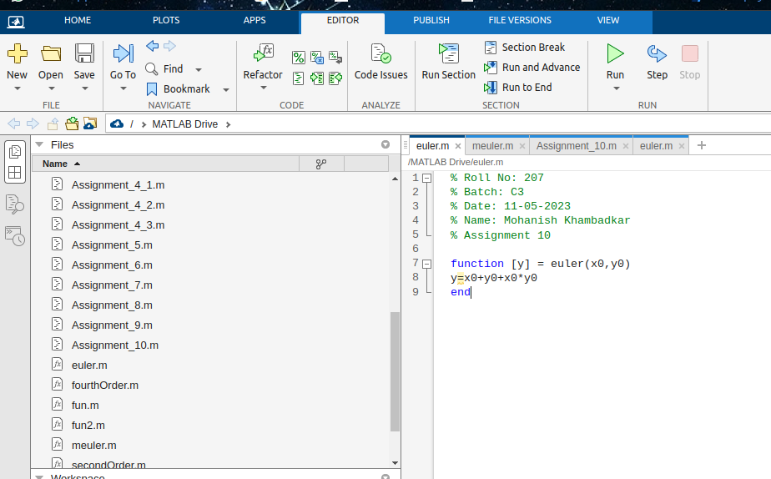end

function [y] = meuler(x0,y0)

y=1-y0

end

